FREQUENCIES
VARIABLES=life
/ORDER= ANALYSIS .

Frequencies

[DataSet1] C:\Program Files\SPSS\GSS93 subset.sav

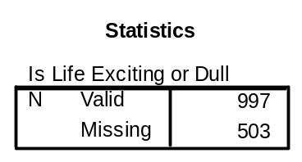

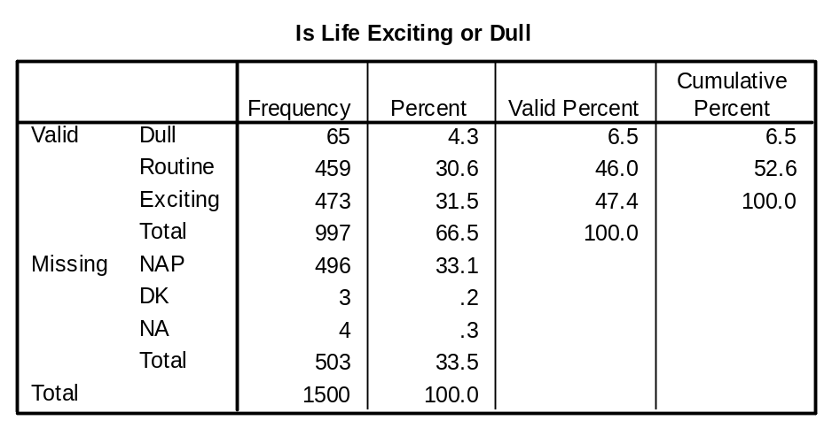

CROSSTABS
/TABLES=life BY sex
/FORMAT= AVALUE TABLES
/STATISTIC=CHISQ
/CELLS= COUNT
/COUNT ROUND CELL .

Crosstabs

[DataSet1] C:\Program Files\SPSS\GSS93 subset.sav

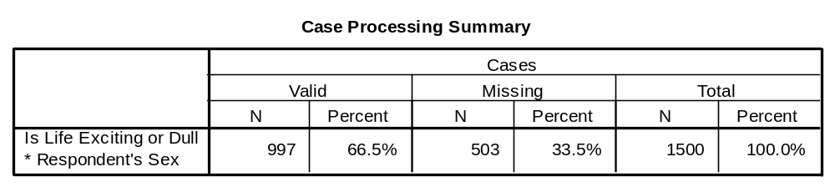

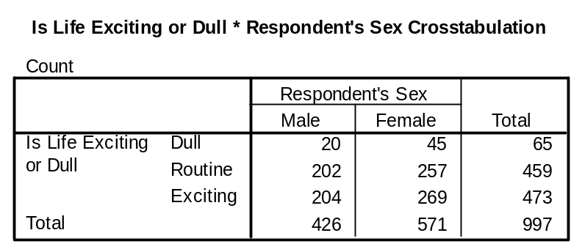

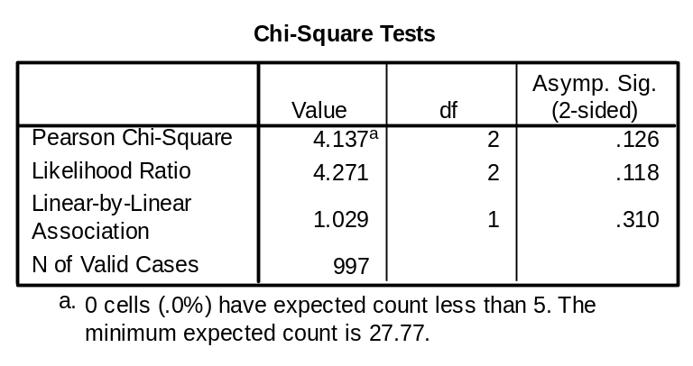
There is no association between sex and life.

CROSSTABS
/TABLES=life BY marital
/FORMAT= AVALUE TABLES
/STATISTIC=CHISQ
/CELLS= COUNT
/COUNT ROUND CELL .

Crosstabs

[DataSet1] C:\Program Files\SPSS\GSS93 subset.sav

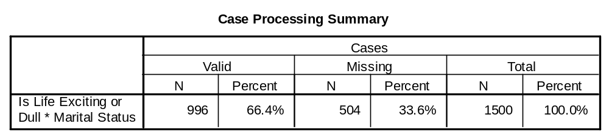

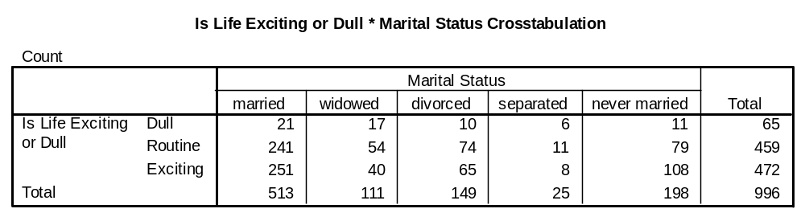

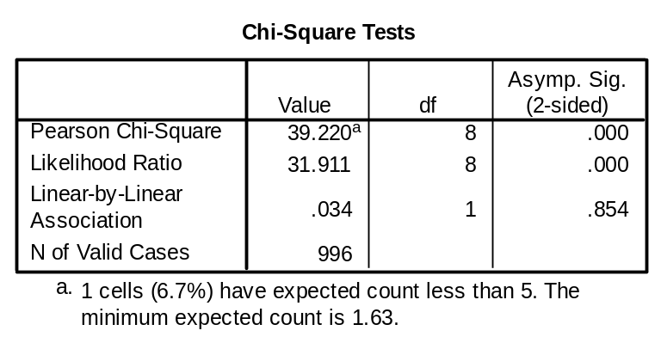
There is an association between marital status and life.

Multinomial Logistic Regression Analysis (Life excitement and marital status)

NOMREG
life (BASE=LAST ORDER=ASCENDING) BY sex marital
/CRITERIA CIN(95) DELTA(0.5) MXITER(100) MXSTEP(5) CHKSEP(20) LCONVERGE(0
) PCONVERGE(0.000001) SINGULAR(0.00000001)
/MODEL
/STEPWISE = PIN(.05) POUT(0.1) MINEFFECT(0) RULE(SINGLE) ENTRYMETHOD(LR)
REMOVALMETHOD(LR)
/INTERCEPT =INCLUDE
/PRINT = FIT PARAMETER SUMMARY LRT STEP MFI .

Nominal Regression

[DataSet1] C:\Program Files\SPSS\GSS93 subset.sav

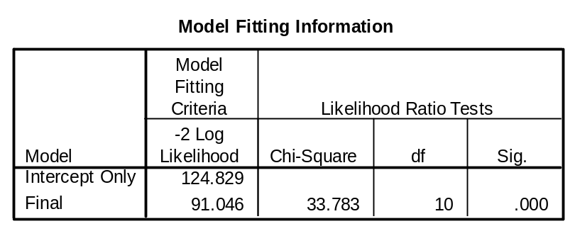

When two IVs are used, there is a model improvement (-2LL became smaller, chi-square=33.783 with df=10, p<0.001). This is similar to omnibus test.

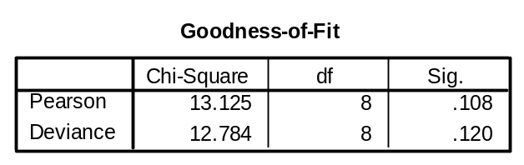

We are looking for a small chi-square with a large p-value. This is similar to Hosmer-Lemeshow Test.
The null hypothesis is Data=the Model. We do not want to reject the null hypothesis.

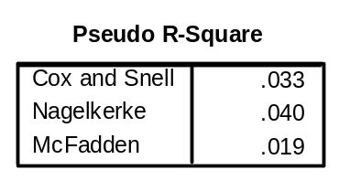

About 4% of the variation of life excitement is explained by sex and marital status.
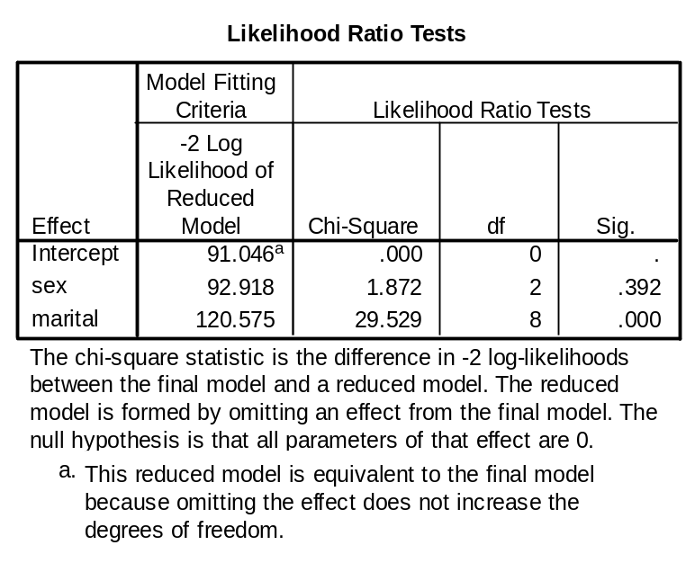
Sex is not significant, but marital status explains life excitement.
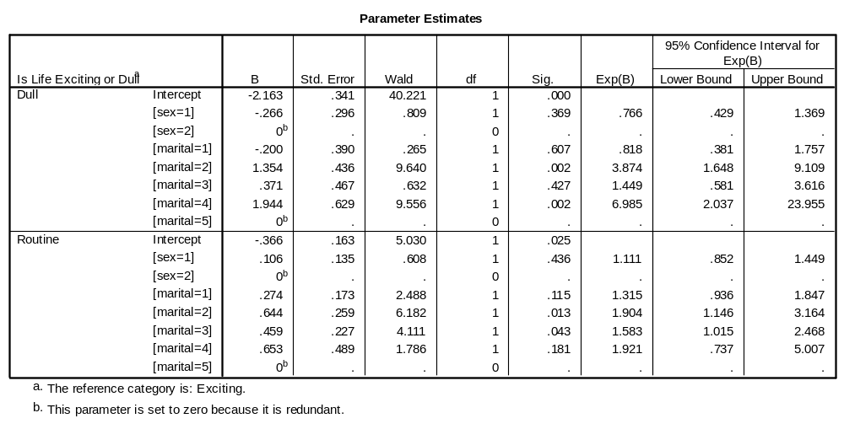

Sex: 1=male, 2=female
Marital Status: 1=married, 2=widowed, 3=separated, 4=divorces, 5=single

Exp (B) for widowed is 3.874, which means “widowed people are 3.874 times more likely than single people to say life is dull as opposed to say life is exciting.

OR of widowed men who said ‘dull’;

O _{Dull}= e ^{-2.163 -0.266 (1) + 1.354 (1)}
= e ^{-1.105} = 0.3312

OR of widowed men who said ‘routine’;

O _{Routine} = e ^{-0.366 + .106 (1) + 0.644 (1)}
= e ^{0.384} = 1.468

O _{Exciting} = 1 (because exciting is a reference category)

Calculations for each P

P(Dull) = 0.3312/ (1+ 0.3312 + 1.468) = 0.1183 or 11.83%
If there are 100 widowed men, about 12 of them say life is dull.

P(Routine) = 1.468/ (1+ 0.3312 + 1.468) = 0.5244
If there are 100 widowed men, about 52 of them say life is routine.

(P Exciting) = 1/ (1+ 0.3312 + 1.468)= 0.3572
Similarly, about 35 widowed men out of 100 will say life is exciting.

0.1183+0.5244+0.3572=1.000 or 100%

Multinomial Regression Analysis (Life excitement and educational degree)

NOMREG
life (BASE=FIRST ORDER=ASCENDING) BY sex degree
/CRITERIA CIN(95) DELTA(0.5) MXITER(100) MXSTEP(5) CHKSEP(20) LCONVERGE
(0.00001) PCONVERGE(0.0001) SINGULAR(0.00001)
/MODEL
/STEPWISE = PIN(.05) POUT(0.1) MINEFFECT(0) RULE(SINGLE) ENTRYMETHOD(LR)
REMOVALMETHOD(LR)
/INTERCEPT =INCLUDE
/PRINT = ASSOCIATION FIT PARAMETER SUMMARY LRT CPS STEP MFI IC .

Nominal Regression

[DataSet1] C:\Program Files\SPSS\GSS93 subset.sav

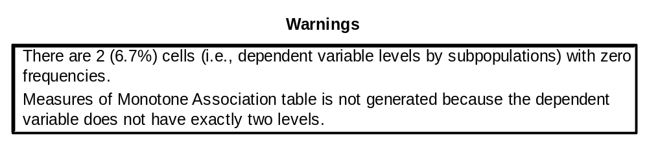
If there are too many cells with zero frequency, you need to develop a different model.

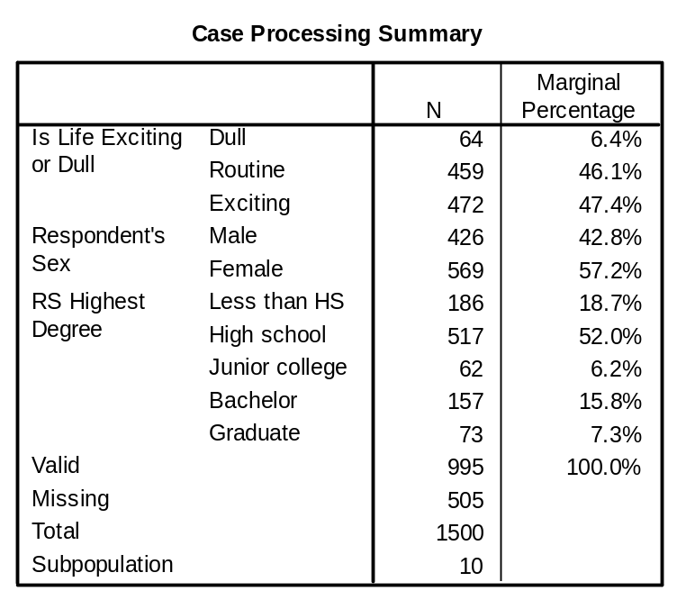

DV: Life excitement. Dull will be a reference category.

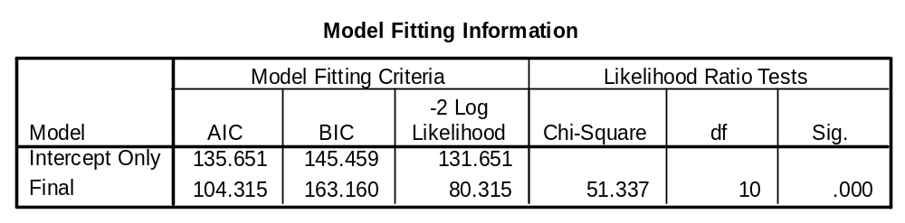

Chi-square change =51.337 with df=10 was statistically significant (p<0.001).

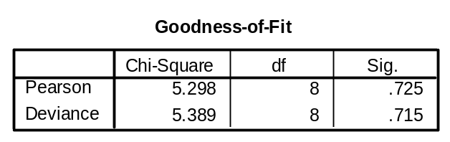

H0: Model=data was not rejected (chi-square=5.298, df=8 was not significant).
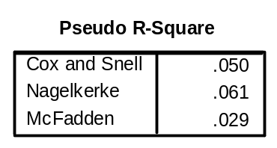
About 6% of the variation of DV is explained by these IVs.
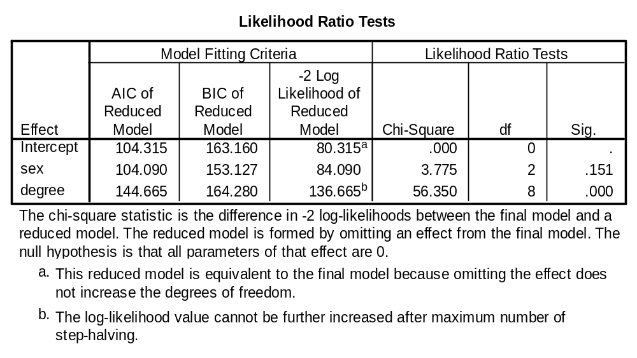

Sex is not significant predictor, but educational degree is.

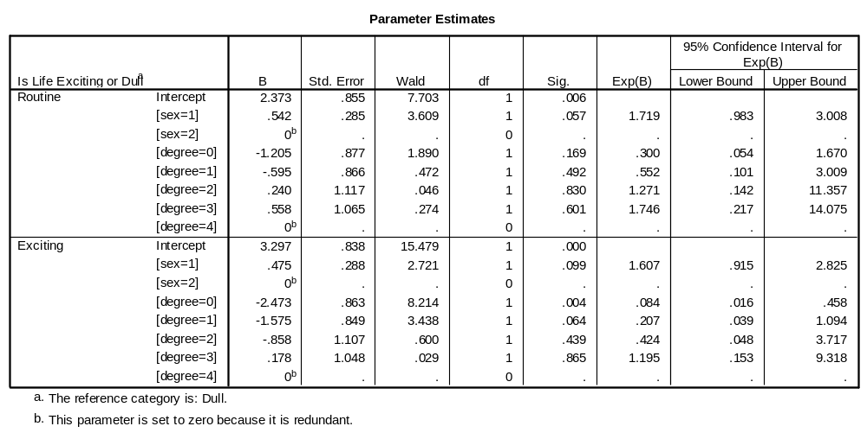
Males are 1.7 times more likely than females to say “life is routine” as opposed to say “life is dull.”

Males are 1.6 time more likely than females to say “life is exciting” as opposed to say “life is dull.”

Those who have less than high school degree are 0.084 times more likely than those who have graduate degree to say “life is exciting” as opposed to say “life is “dull.”

Those who have less than high school degree are 11.9 (1/0.084) times more likely than those who have graduate degree to say “life is dull” as opposed to “life is exciting.”

